Whack-A-Mole Game

1. Preparation
- Set the Speed: Flip all 16 Slide Switches (at the bottom) UP to start in "Easy Mode." If they are all down, the game will be too fast to see!
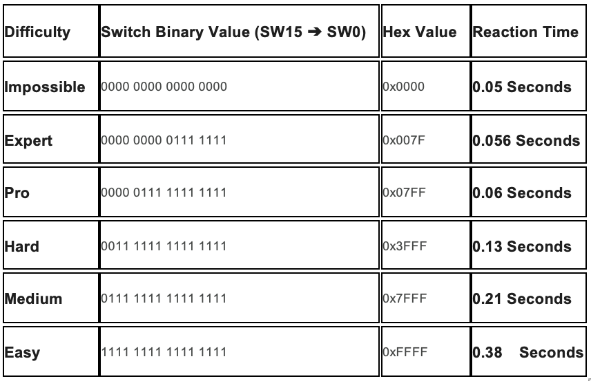
- Start the Game: Press any of the five pushbuttons to begin. Make sure to let go of the button immediately after pressing start, or you might "miss" the first mole.

2. How to Play
A single LED will light up on the right side of the board. You must press the matching button before the timer on the red display hits zero.

3. The Rules
- Be Fast: The red number in the center is your countdown. If it reaches zero before you press the button, you lose!
- Be Accurate: If you press the wrong button (e.g., pressing "Up" when the "Down" LED is lit), it is an instant Game Over.
- The 4 buttons: In order, Top – Left – Right - Bottom
- Survival: Every time you get one right, the game gets a little bit faster.

4. Winning and Losing
- Success: If you hit the right button, your score will be shown briefly, then a new mole will appear.
- Game Over: If you lose, all LEDs will be lit with final score shown
- Final Score: Your total points will stay on the red display so you can see how you did before the game resets to the beginning.

